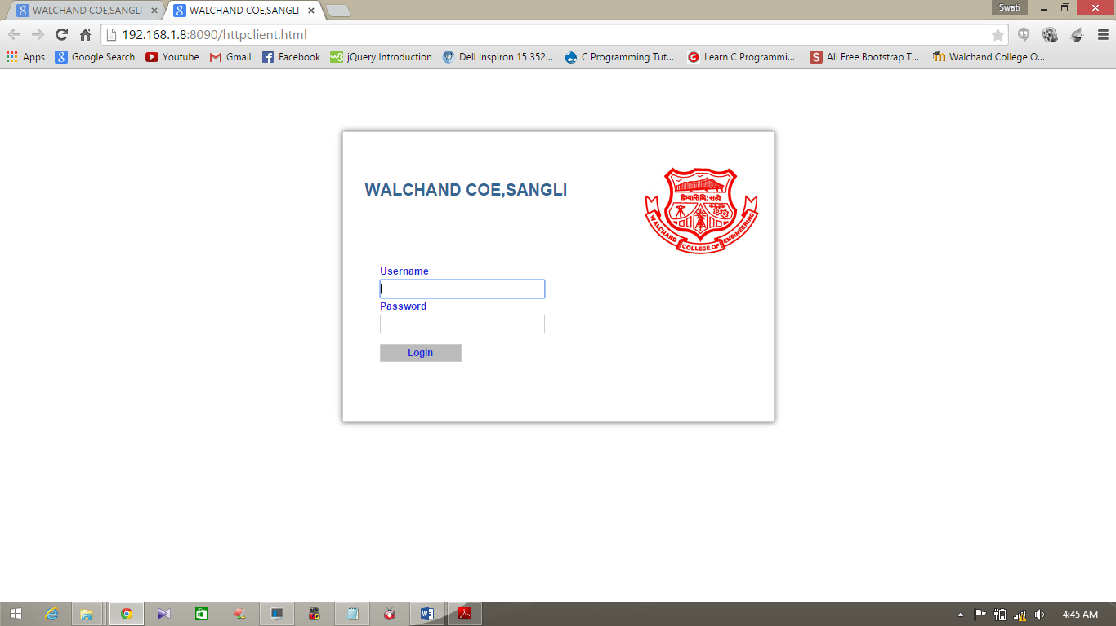

Walchand College of Engineering, Sangli

(An Autonomous Institution)

A Project Report

on

**Parallel Event Matching algorithm for Content Based Publish/Subscribe System Using covering Relationships.**

Submitted To

DEPARTMENT OF Computer SCIENCE & ENGINEERING

Walchand College of Engg. Sangli

A project report submitted in fulfilment of the Mega Project

For the degree of

Bachelor of Technology in Computer Science and Engineering

By

### Miss. Dhanashree Gaman Chavan. ( 2013BCS208 )

Miss. Sonali Vitthal Jagtap. (2013BCS211)

Miss. Abhilasha Pandurang Patil. (2013BCS217)

Under The Guidance

Of

Prof. Mrs. M. A. Shah

May 2016

**CERTIFICATE**

This is to certify that, The Project Report entitled,

**Parallel Event Matching algorithm for Content Based Publish/Subscribe System Using covering Relationships.**

Submitted By:

### Miss. Dhanashree Gaman Chavan.

Miss. Sonali Vitthal Jagtap.

Miss. Abhilasha Pandurang Patil.

Is a bonafide record of their own work performed out by them in fulfillment of the final year B.Tech project in Computer Science and Engineering as specified in the curriculum prescribed by Walchand College of Engineering, Sangli.

Mrs. M. A. Shah Dr. B.F.Momin

Guide, HOD,

Dept, OF CSE, WCE, Dept. of CSE,WCE,

Sangli Sangli

**DECLARATION**

We, the undersigned, hereby declare that the project report entitled,

**Parallel Event Matching algorithm for Content Based Publish/Subscribe System Using covering Relationships.**

Written and submitted by us to Department of Computer Science and Engineering, Walchand College of Engineering, Sangli as a complete fulfillment for Mega Project under the guidance of Prof. M. A. Shah is our sincere work. The empirical results in this project report are based on the data collected by us. We understand that any type of copying is liable to be punished as the authorities deem fit.

**Date :**

**Place :** Walchand College of Engineering, Sangli.

**Names :**

Miss. Dhanashree Gaman Chavan. (2013BCS208)

Miss. Sonali Vitthal Jagtap. (2013BCS211)

Miss. Abhilasha Pandurang Patil. (2013BCS217)

**Acknowledgement**

The Project report on “Parallel Event Matching algorithm for Content Based Publish/Subscribe System Using covering Relationships” is outcome of guidance, moral support and devotion bestowed on us throughout our work. For this we acknowledge and express our profound sense of gratitude and thanks to everybody who have been a source of inspiration during the project preparation. First and for most I offer our sincere phrases of thanks with innate humility to Dr.B. F. Momin, Head Of Department, Computer Science and engineering, Walchand College Of Engineering , Sangli & guide of our Project for providing help whenever needed. The consistent guidance and support provided byprof.

M.A.Shah, is very thankfully acknowledged for key role played by her in providing us with precious ideas, suggestions and help that enabled in shaping the project work.

If we can say in words I must at the outset tender our intimacy for receipt of affectionate care to Walchand College Of Engineering , Sangli for providing such a stimulating atmosphere and wonderful work environment.

**Name:**

Miss. Dhanashre Gaman Chavan (2013BCS208)

Miss. Sonali Vitthal Jagtap (2013BCS211)

Miss. Abhilasha Pandurang Patil (2013BCS217)

**Abstract**

Content-based publish/subscribe systems allow subscribers to specify events of interest based on event contents, beyond pre-assigned event topics. When networks of servers are used to provide scalable content-based publish / subscribe services, the flexibility of partitioning existing subscriptions and routing new subscriptions among multiple servers to optimize various performance metrics including total network traffic, load balancing, and system throughput. How to efficiently match high volumes of events against large numbers of subscriptions is a key issue for large-scale content-based publish/subscribe systems. The system efficient and applied matching algorithm that uses multi-dimensional indexing mechanism to speed up constraints query and exploits the covering relations between constraints to reduce unnecessary matching. Experiments show that algorithm is significantly more efficient and scalable than other common used matching algorithms.

**Contents**

|  |  |  |
| --- | --- | --- |
| Chapter No. | **Topic Name** | **Page No.** |
| Chapter 1 | INTROUCTION   * 1. Problem Definition   2. Exiting System Limitation   3. Project Objective | 8 |
| Chapter 2 | Theory Of  2.1 General Specifications  2.2 Detail Specifications | 10 |
| Chapter 3 | 3.1 Hardware  3.2 Software | 12 |
| Chapter 4 | System Design  4.1 Design Architecture  4.2 Design Algorithm | 13 |
| Chapter 5 | Methodology  5.1 Requirement Specifications  5.2 Implementation steps  5.3 Coding  5.4 Screenshots  5.5 Testing Manual | 19 |
| Chapter 6 | System Specifications  6.1 Software Interface | 21 |
| Chapter 7 | Implementation  7.1 Screenshots | 23 |
| Chapter 8 | Conclusion and Future Scope | 24 |

List of Figures

|  |  |  |  |
| --- | --- | --- | --- |
| No | Name of figure | | Page No |
| 1. | Publish/Subscribe system | |  |
| 2. | Data structure of index matching algorithm | |  |
| 3. | Overall Structure | |  |
| 4. | UML Diagram | |  |
| 4.1 | Class Diagram |  |
| 4.2 | Use case Diagram |  |
| 4.3 | Sequence Diagram |  |
| 5. | Praposed Structure | |  |
| 6. | Programming Model of MPI | |  |